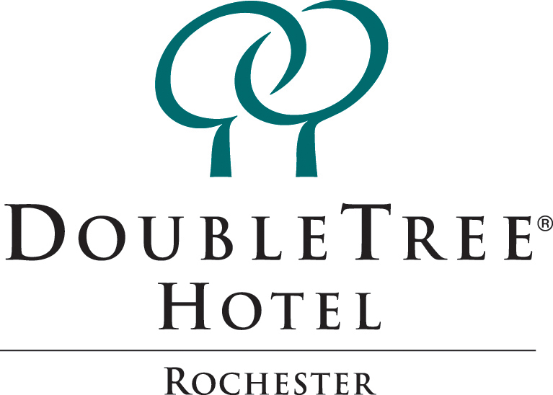

Where Champions Rest

- 249 Newly Renovated Guestrooms

- Bistro 252 Restaurant – Open from 6am to 10pm

- Atrium Lounge

- Heated Indoor Pool

- Hot Tub and 24-hour Fitness Center

- In-room Coffee Makers

- On Command Movies

- Irons and Ironing Boards

- Our Famous Warm DoubleTree Chocolate Chip Cookie upon Check-in

To reserve your overnight hotel rooms please contact Shannon at 585-475-1510 EXT 156

 1111 Jefferson Road
Rochester, NY 14623
(585) 475-1510
1-800-222-TREE

