Website Page/League Sponsors Needed

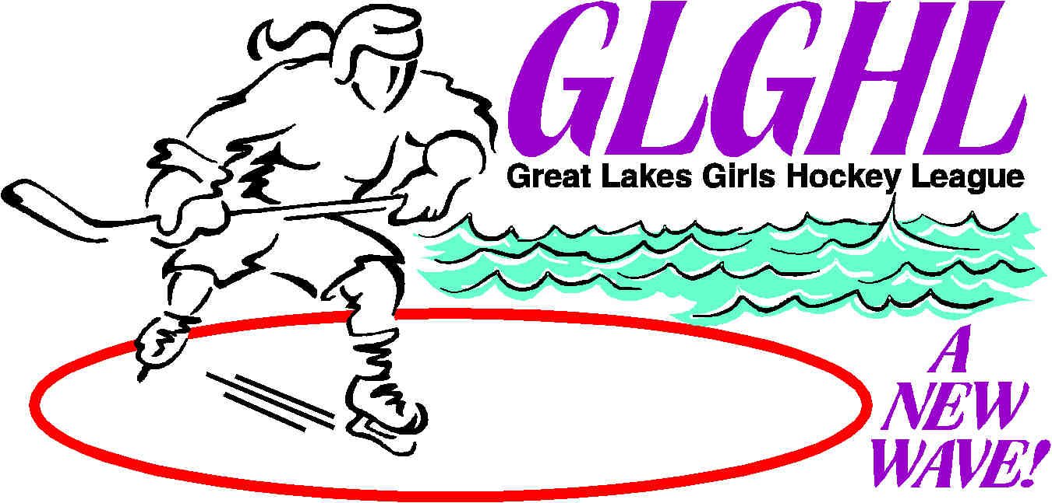

Advertisers! The Great Lakes Girl’s Hockey League is looking for a few good web page sponsors. You can have a banner displayed on one or several pages of www.glghl.com.

We would like to have a leader board style banner of 728 x 90 pixels in size, and can it may be animated have a live link to your website.

You will see several pages on the website with the following announcement:
Sponsor This Page!
www.glghl.com is growing. The site generates over 15,000 hits annually. Reach an audience that covers Upstate NY, PA, OH, and Ontario, Canada. Ideal for fundraising & hockey equipment companies, restaurants & hotels, tournament brokers and anything related to hockey. Proceeds from ads help to maintain the website and administrative costs. Be the first - buy an ad now! For more info email us at glghlnet@yahoo.com
Or it will have the following 2 banners on that particular page.





These are pages which you can have a banner ad on. We will limit the amount of banners to two (2) per page and try not to have the same categories of advertisers on the same page.

The duration will last for one season. Generally the season starts September 1st and runs through August of the following year. 1 year maximum total time your ad will appear.

The home page leader board banner ad will be $ 150.00 each banner for one year.

Interior pages the leader board banner ad will be $ 100.00 each for one year.

Side Banner 120 x 240 pixel banners will be $125.00 for home page and $75.00 for interior pages.

Interior pages such as Schedules, Standings, GLGHL News, Rink Locations and Tournaments, are the interior pages that generate web traffic.

The web site generates over 15,000 hits annually and is expected to grow in the future.

GLGHL is New York States largest girl’s hockey league.

Our current league make-up is 38 teams from 23 different associations across Western & Central New York State, Pennsylvania, and Ohio. This is great regional exposure.

These banner ads are ideal for restaurants & hotels, tournaments, fundraising, sportswear and trophy companies, car dealerships, or anything hockey related including tournament brokers, sporting goods, etc.

Be the first company to show your loyal support to Girl’s Hockey!

Contact: Bill Pavone, Webmaster
bpavone@glghl.com
716-875-8136 or 716-578-8449

