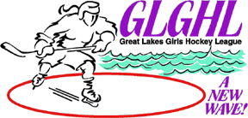

Monday, November 8, 2010 - 7:30 pm

Holiday Twin Ice Rinks
Cheektowaga, New York

Agenda

- Welcome/Roll Call/Sign in sheet
  - Quorum
Old Business
- League fees due
- USA Hockey Rosters due
  - Commissioners to forward copies of all USA Hockey rosters to League Secretary by 11/15/2010.
- Saturday, December 11, 2010 is Western New York Hockey Day
  - Update Buffalo Regals
- Future Stars Program
  - Conference Call 11/11/2010
  - Play to start December1, 2010
    - Batavia, Erie, Hamburg, Rochester, West Seneca

- Curfew Times – coaches must initial on game sheet, record time left if curfewed
  - Protest Filed

- FLAG – Finger Lakes Girls Hockey League

New Business

- Divisional Playoffs
- Game reporting
- Financial Report

- Division Commissioners’ Reports

- Misconduct and Game Suspension Reporting

  - All league teams must complete on-line report for all misconduct and game suspensions involving their team.

- USA Hockey Code of Conduct

- Open discussion

  - Next Meeting Date and Location
    - December 13, 2010
    - Facility – TBD

  - Motion to Adjourn

